University of Colorado at Boulder
CHEM 1021: Exam 3 – Tuesday, April 8, 2025

Please read this cover page and follow the instructions.
Do not open the exam until you are told to do so.

On the computer graded answer sheet, enter your name and student ID number in the appropriate boxes. For section number, enter a zero followed by your three-digit lab section number (0191). Then fill in the corresponding bubbles below your name, ID number, and lab section.
Answer all questions on the computer graded answer sheet by filling in the proper bubble with a No. 2 pencil. If you change an answer, erase the undesired mark thoroughly. Mark only the best answer to each question.
Cell phones must be turned off; all electronic devices must be placed in a backpack or on the floor, and may not be accessed during the exam. Students violating this policy will be asked to leave and will receive a zero for the exam.
A Periodic Table is printed on the back of this cover sheet. There are 6 exam pages (double-sided) with 25 multiple choice questions and 1 blank page for scratch paper. When you are instructed to begin the exam, please check that you have all pages.

When you are finished, give the answer sheet to your teaching assistant. You may take the exam with you. Good luck!

Important information

Avogadro’s number = 6.022 x 10²³

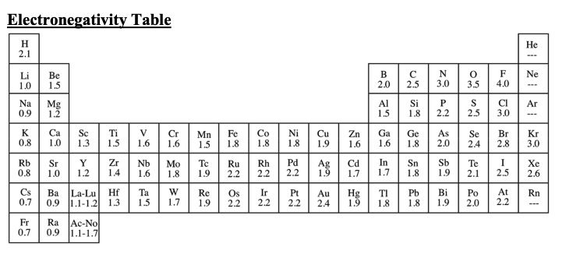
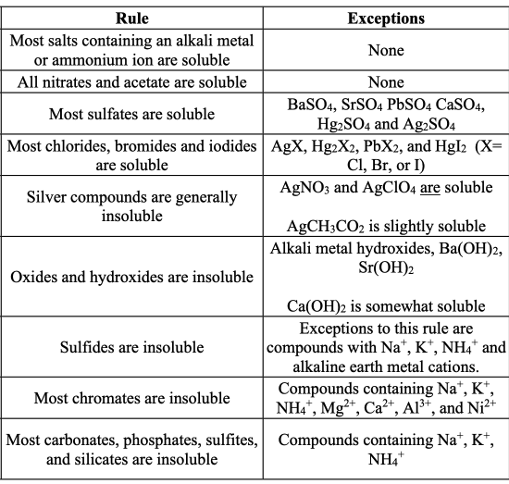
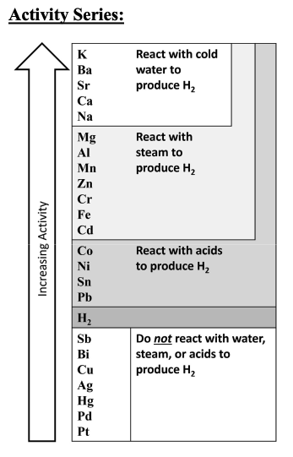
Solubility Rules:
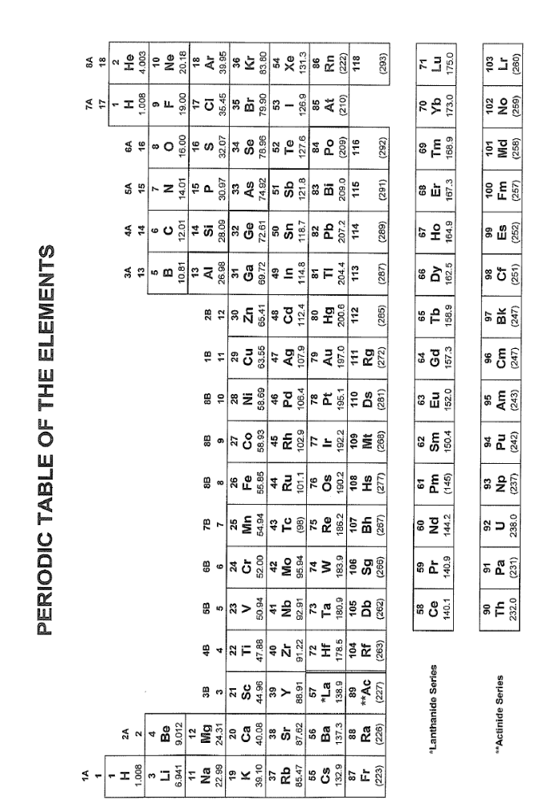

- Consider the ions formed from alkali metals: Li, Na, K and Rb. Select the correct arrangement from smallest to largest.

- Rb⁺< Na⁺<K⁺< Li⁺
- Li⁺<Na⁺<K⁺<Rb⁺
- Rb⁺<K⁺< Na⁺< Li⁺
- Na⁺<Li⁺<Rb⁺< K⁺

- Which of the following atoms has the smallest atomic radius?

- Silicon
- Chlorine
- Magnesium
- Phosphorous

- Which of the following would be expected to have the greatest first ionization energy?

- Alkali metals
- Alkali Earth metals
- Group III elements (B, Al, etc.)
- Halogens

- Write the chemical formula for iron (III) oxide.

- Fe₂O₃
- Fe₃O₂
- FeO
- Fe₃O₃

- Write the chemical formula for Nitrous Acid.

- HNO₃
- HNO₂
- HNO
- H₃N

- The correct name for the acid, H₃P is ____________.

- Perphosphoric acid
- Phosphorous acid
- Phosphoric acid
- Hydrophosphoric acid

- The correct name for the compound, CuS is ____________.

- Copper (II) sulfate
- Copper (I) sulfide
- Copper (II) sulfide
- Copper (II) sulfate

- The correct name for the neutral compound, ClO₃ is ___________.

- Chlorine trioxide
- Chlorine oxide
- Chlorate
- Monochlorine trioxide

- Consider the following chemical reaction. When balanced the total of the coefficients in front of each species adds to ________.

H₂CO₃ + NaOH → Na₂CO₃ + H₂O

- 4
- 5
- 6
- 7

- Consider the following chemical reaction. When balanced what is the coefficient in front of the molecule ammonia?

H₂ + N₂ → NH₃

- 1
- 2
- 3
- 4

- Consider 100.0 mL of a 0.100 M NaOH solution. How many grams of NaOH are in the solution?

- 400. g
- 0.0400 g
- 4.00 g
- 0.400 g

- Consider a stock solution of a 0.100 M NaOH. How much of the stock solution is necessary to create 50.0 mL of a 0.0500 M NaOH solution?

- 25.0 mL
- 0.250 mL
- 10.0 mL
- 1.00 mL

- A metal bar made from iron is placed in a solution of lead (II) nitrate. Does a reaction occur and if so, what are the products?

- A reaction does not occur
- A reaction occurs; the products are solid iron and solid lead
- A reaction occurs; the products are aqueous iron and solid lead
- A reaction occurs and the products are solid iron and aqueous lead

- Carbonic acid typically breaks down into _____________ when it is a product of a chemical reaction.

- Liquid water and gas phase carbon dioxide
- Solid carbon, gas phase hydrogen and gas phase oxygen
- Solid carbon and liquid water
- Gas phase carbon dioxide and gas phase hydrogen

- Select the weak acid.

- Hydrobromic acid
- Hydrochloric acid
- Hydroiodic acid
- Hydrofluoric acid

- Select the weak base.

- Sodium hydroxide
- Potassium hydroxide
- Ammonia
- Strontium hydroxide

- Consider the reaction between sodium hydroxide and phosphoric acid (NaOH + H₃PO₄). What are the spectator ions?

- Sodium and phosphate ions
- Hydroxide and hydrogen ions
- Sodium and hydrogen ions
- All ions spectate (no reaction occurs)

- You mix aqueous silver nitrate and aqueous sodium chloride in the laboratory. Does a precipitate form, and if so, what is the identity of the precipitate?

- No precipitate forms
- A precipitate of silver sodium forms
- A precipitate of nitrate chloride forms
- A precipitate of silver chloride forms

- You burn a hydrocarbon (such as octane) in the presence of oxygen. What are the products of the reaction assuming complete combustion of the hydrocarbon?

- water
- carbon dioxide
- water and carbon dioxide
- hydrogen, oxygen and carbon

- Consider 5.23 x 10²⁴ molecules of carbon dioxide. Convert this number of molecules into grams of carbon dioxide.

- 10.9 g
- 382 g
- 45.1 g
- 190 g

- Which of the following metals will react with acid to produce hydrogen gas?

- Aluminum
- Nickel
- Both aluminum and nickel
- Neither aluminum nor nickel

- Consider the ionic compound Fe(NO₃)₂. Calculate the percentage by weight of iron in the compound.

- 31.1 %
- 14.8 %
- 23.8 %
- 40.2 %

- Which chemical formula listed below represents an empirical formula?

- P₄O₁₀
- N₂O₄
- CO₂
- H₂O₂

- How many grams of oxygen are present in 100.0 grams of nitric acid?

- 28.12 grams
- 56.89 grams
- 63.10 grams
- 76.19 grams

- Consider 100.0 grams of sulfuric acid. How many moles of sulfuric acid is this?

- 0.9823 moles
- 1.020 moles
- 1.432 moles
- 2.091 moles

